ITA0407- R Programming

Lab Programs

1.Create numeric, character, and logical vectors and display type and content.

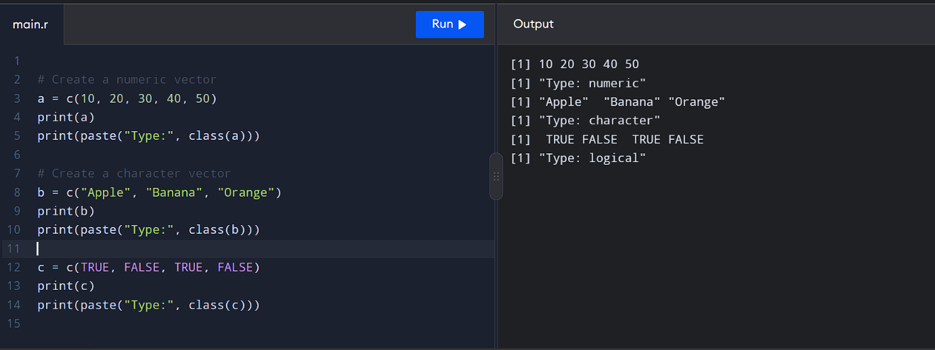

2.Create labeled matrices (5×4, 3×3, 2×2) filled by row/column.
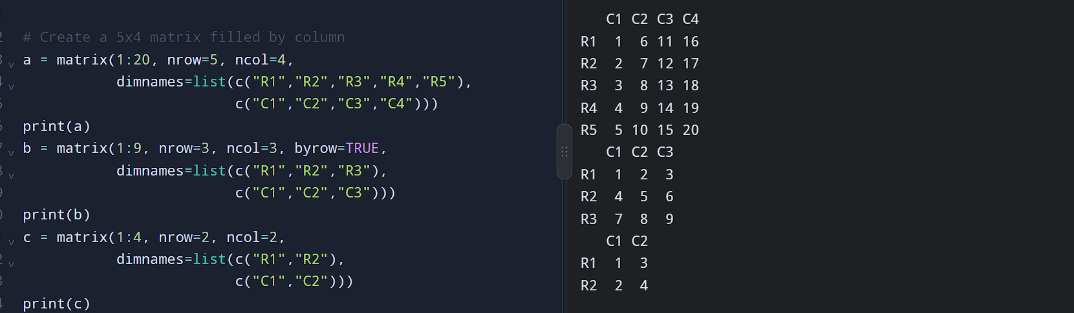

3. Write an R program to create and display a 3D array with specified rows,
columns, and tables.
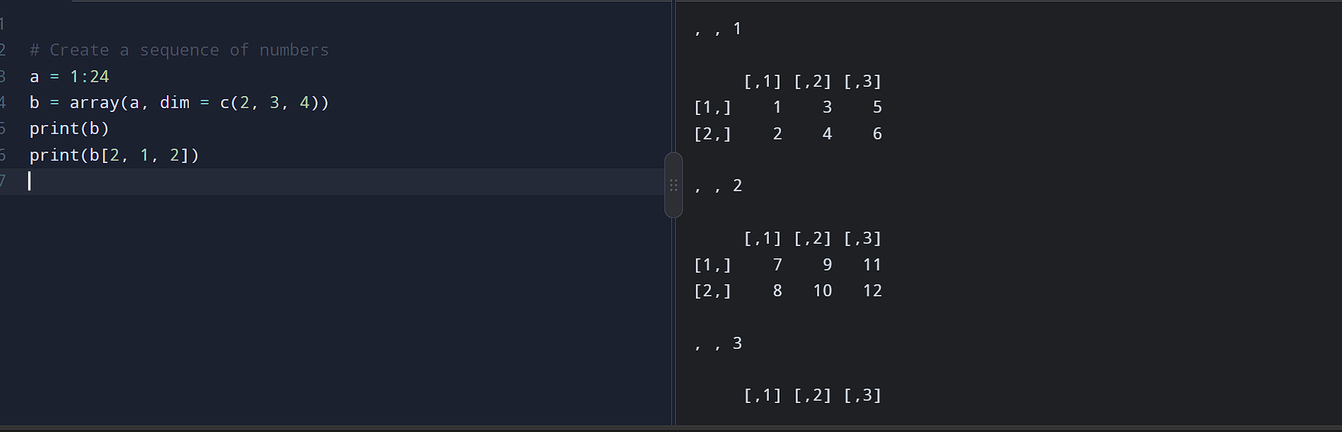

4. Create arrays from vectors with dimension names, print specific elements.
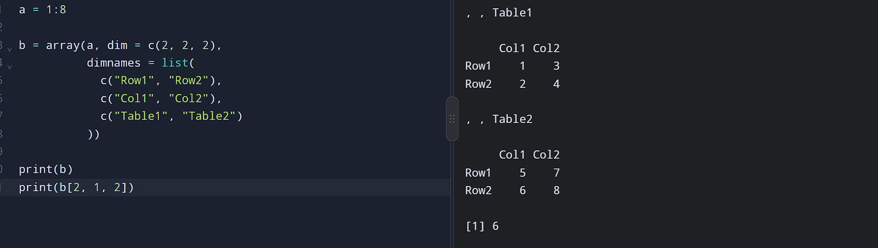

5. Create and manipulate factor variables (e.g., women’s dataset heights, random.
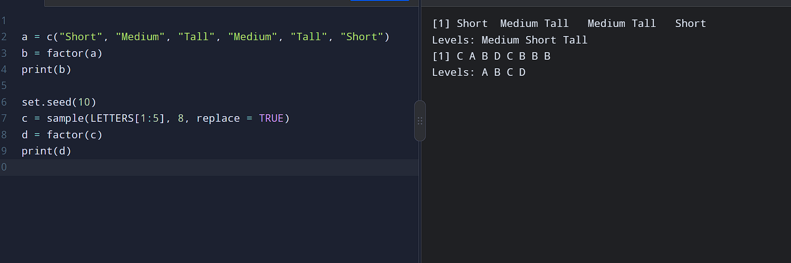

6.. Create an R list containing vectors, matrices, and functions; display contents.
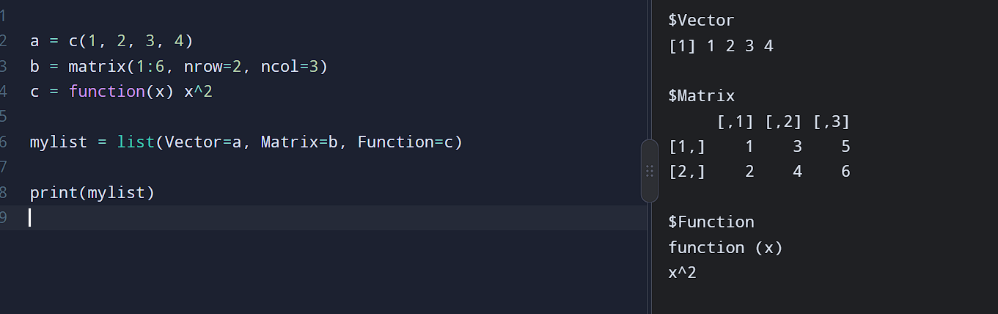

7. Write R programs for basic tasks: Factors of a number, generate a vector of 10.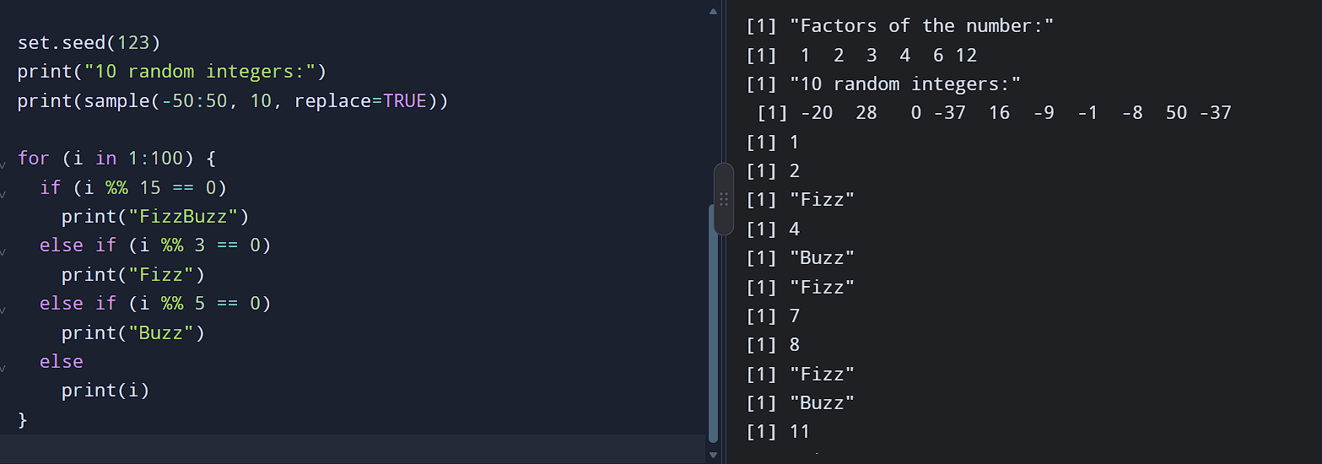

8. Generate random numbers from a normal distribution; count occurrences.
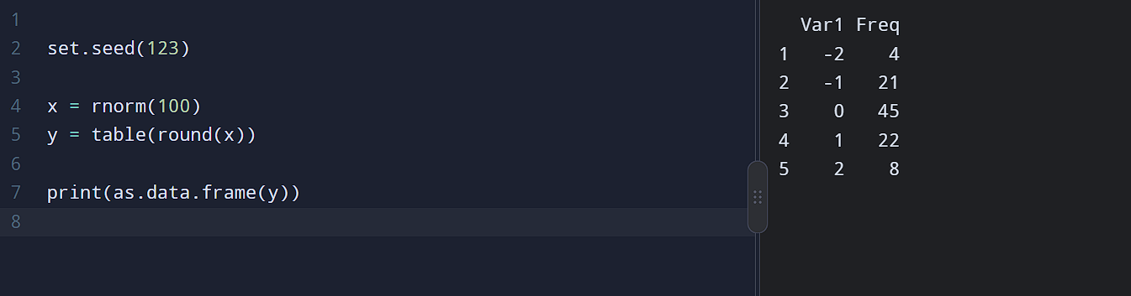

9. Create empty plots with specified axis limits.
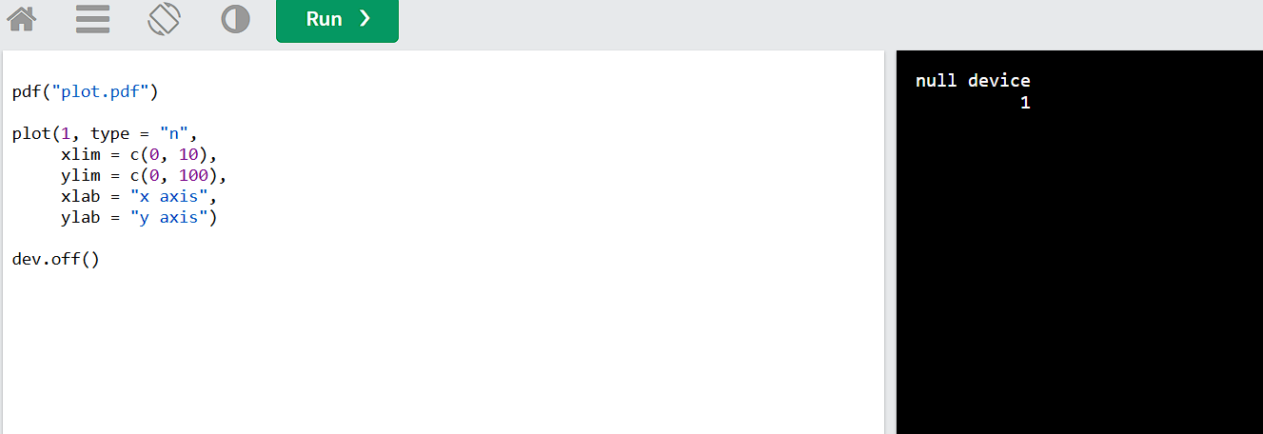

10. Create and explore a data frame exam_data with name, score, attempts, and qualifying fields. Perform extract, add row/column, sort, save to file.

